SpotifyHelper: A Spotify FAQ Chatbot Using LangChain, Chroma, and Ollama
Barbara Kendall
September 28, 2026

Name and Purpose
I call this app SpotifyHelper, a natural language processing (NLP) chatbot designed to answer frequently asked questions about Spotify. The purpose of the chatbot is to provide users with answers to common questions about Spotify features, subscriptions, offline listening, account security, login problems, connected devices, and troubleshooting.
SpotifyHelper uses a retrieval-augmented generation (RAG) approach rather than relying only on the general knowledge of a large language model. When a user asks a question, the application searches a collection of Spotify FAQ records for information related to the question. Relevant records are supplied to a local large language model, which generates an answer based on the retrieved information.
An important goal of the application is to reduce hallucinations. The chatbot is instructed to answer using the supplied FAQ information instead of inventing random Spotify policies or features. A relevance threshold is also used so that questions unrelated to the FAQ dataset can be rejected instead of forcing the model to answer them.

NLP and LLM Methods
SpotifyHelper combines semantic search, text embeddings, vector similarity, prompt engineering, and a large language model.
The first NLP technique used is text embedding. Each FAQ question and answer is converted into a numerical vector representation using the nomic-embed-text embedding model through Ollama. Embeddings represent the semantic meaning of text, allowing questions with different wording but similar meanings to be compared.
For example, a user can ask, “How many songs can I download?” even though the stored FAQ uses the word “tracks.” Semantic retrieval allows the application to recognize that these phrases have similar meanings.
The embeddings are stored in a Chroma vector database. When a user submits a question, the question is also converted into an embedding. Chroma then performs a similarity search to retrieve up to three FAQ records that are most closely related to the user's question.
The application uses LangChain to connect the retrieval process, prompt, and language model. LangChain's document structure is used to store the FAQ text and metadata, while a ChatPromptTemplate provides instructions and retrieved context to the language model.
The generative component uses the Llama 3.2 3B model through Ollama. Running the model with Ollama allows the chatbot to operate locally rather than requiring a paid cloud API. The model receives the user's question along with the retrieved FAQ records and generates a natural-language response.
Prompt engineering was also important during development. During testing, the model initially failed to return a numerical answer that existed in the retrieved context and later incorrectly described the download limit as unlimited. The prompt was therefore revised to instruct the model to preserve numbers, quantities, restrictions, and other important factual details exactly as represented in the FAQ records.
A second safeguard was added after testing an unsupported question. The application uses similarity relevance scores and removes results below a relevance threshold of 0.35. If no FAQ record meets the threshold, the chatbot responds that the information is not available in its Spotify FAQ sources. This reduces the likelihood of generating an unsupported answer.

Dataset Information
The dataset consists of 20 manually curated FAQ records based on information from Spotify's official support resources. The records cover common topics including billing, Premium features, offline listening, account access, security, troubleshooting, Spotify Connect, devices, and audio features.
Each record contains four main fields:
Question: A string containing a common Spotify-related question.
Answer: A string containing the summarized answer to the question.
Source: A string containing the URL of the official Spotify Support page associated with the information.
Topic: A categorical string identifying the general subject of the record, such as billing, offline, account, security, devices, or troubleshooting.
Before the records are inserted into the vector database, basic text preprocessing is performed. A regular expression normalizes unnecessary whitespace in the question and answer text. The cleaned question and answer are then combined into a LangChain Document. Metadata including the source, topic, and a unique numerical ID is stored with each document.
The dataset intentionally uses official Spotify support material so that responses are based on product-specific information rather than unrestricted general web content. For example, Spotify's current offline-listening documentation explains Premium downloading, device limits, and offline requirements, while its account-security documentation provides steps for securing an account that may have been accessed by another person.
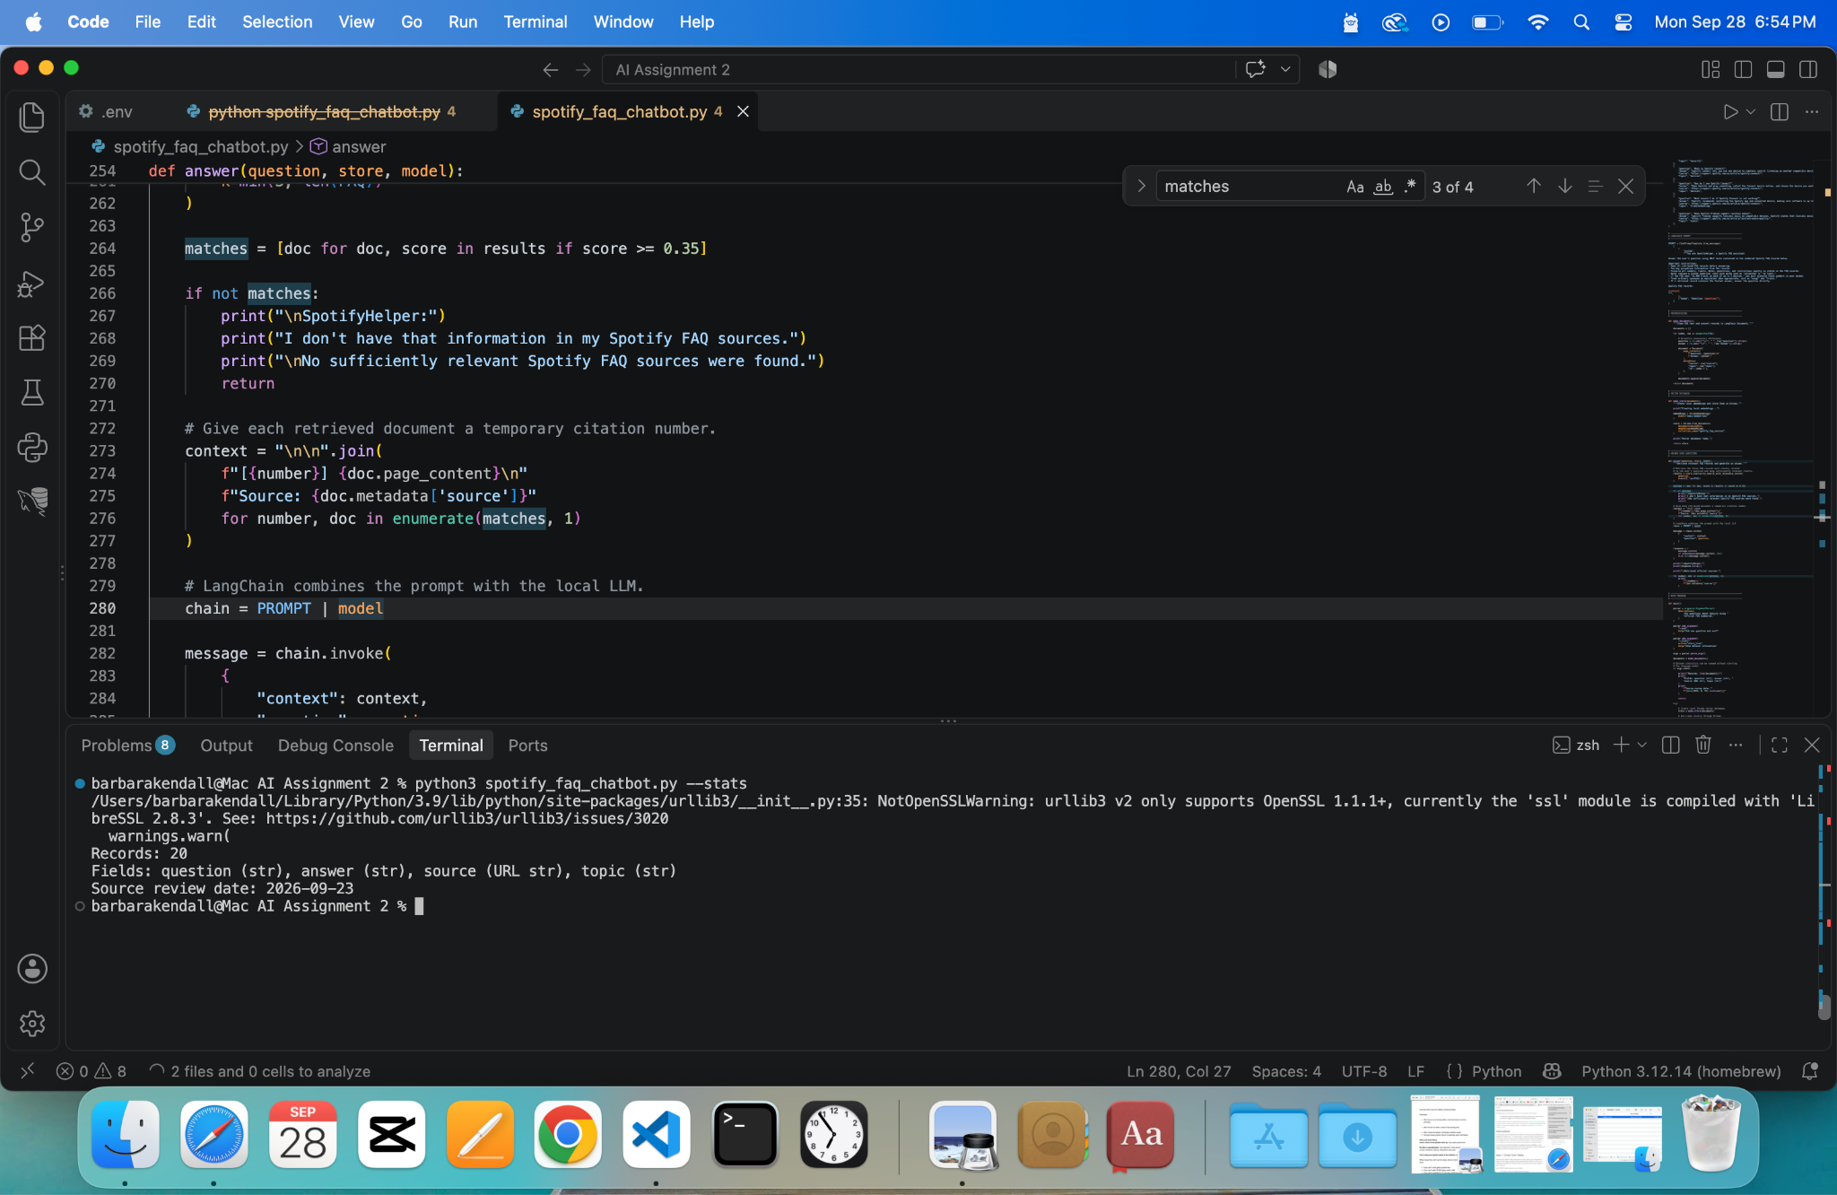
Figure 1. SpotifyHelper dataset statistics showing 20 FAQ records and the dataset fields.

Libraries, Toolkits, and Frameworks
The application was written in Python and uses several libraries and frameworks.
LangChain Core provides the Document and ChatPromptTemplate components used to organize retrieved information and construct prompts for the language model.
LangChain Ollama connects the Python application to locally installed Ollama models. ChatOllama is used for the Llama 3.2 3B language model, while OllamaEmbeddings provides access to the nomic-embed-text embedding model.
LangChain Chroma connects the application to the Chroma vector database.
Chroma stores the embedded FAQ documents and performs semantic similarity searches when questions are submitted.
Ollama runs both the language model and embedding model locally. This eliminates the need for a paid LLM API for this project.
Python's built-in argparse module is used to provide command-line options, re is used for text preprocessing, sys assists with error handling, and datetime is used for dataset information.

Application Design and Implementation
SpotifyHelper follows a retrieval-augmented generation pipeline.
First, the program stores the FAQ information as structured Python records. The make_documents() function preprocesses each record by removing unnecessary whitespace and converting the question and answer into a LangChain Document. The source, topic, and record ID are retained as metadata.
Next, the make_store() function creates embeddings using the local nomic-embed-text model. Chroma stores the resulting document embeddings and creates the searchable vector database.
When a user submits a question, the answer() function performs a semantic similarity search. Up to three potentially relevant FAQ records are retrieved along with their relevance scores. Records that do not meet the minimum relevance threshold are removed.
If no sufficiently relevant records remain, the program does not send unrelated information to the language model as if it were valid context. Instead, it displays:
“I don't have that information in my Spotify FAQ sources.”
If relevant documents are available, they are combined into numbered context records. The user's question and retrieved context are inserted into a LangChain prompt and passed to Llama 3.2 3B through ChatOllama.
The prompt instructs the model to use only the supplied FAQ information, preserve important numerical facts and restrictions, and avoid inventing unsupported information. The application then displays the generated response followed by the official sources associated with the retrieved FAQ records.
The program supports three primary modes. The standard interactive mode allows the user to continue asking questions until entering quit or exit. The --ask option allows a single question to be submitted from the command line. The --stats option displays basic information about the FAQ dataset.

Instructions for Running the Application
SpotifyHelper requires Python, Ollama, the required Python packages, and the two local Ollama models.
The necessary Python packages include langchain-core, langchain-ollama, and langchain-chroma.
The required Ollama models can be installed with the following commands:
ollama pull llama3.2:3b
ollama pull nomic-embed-text
From the project directory, the interactive chatbot can be started with:
python3 spotify_faq_chatbot.py
The application displays a You: prompt where a Spotify-related question can be entered. Entering quit or exit closes the application.
A single question can also be tested with:
python3 spotify_faq_chatbot.py --ask "Can I listen to Spotify offline?"
Dataset information can be displayed with:
python3 spotify_faq_chatbot.py --stats

Results
Testing demonstrated that SpotifyHelper successfully retrieved relevant FAQ records and generated useful answers for supported questions.
One test asked:
“How many songs can I download?”
Even though the dataset uses the term “tracks,” semantic retrieval successfully connected the user's wording with the relevant offline-listening record. The chatbot correctly responded that Spotify Premium users can download as many as 10,000 tracks on each of up to five different devices. This result is consistent with Spotify's official offline-listening documentation.
Another test asked:
“I think someone hacked my account. What should I do?”
The chatbot retrieved the account-security FAQ and recommended resetting the password, signing out everywhere, reviewing connected third-party applications, and using a strong password that is not reused on other services. These actions are consistent with Spotify's account-security guidance.
The chatbot was also tested using:
“Can I listen to Spotify offline?”
It successfully explained that Premium users can download supported content for offline listening and that Spotify Free users can download podcasts but not music for offline listening.
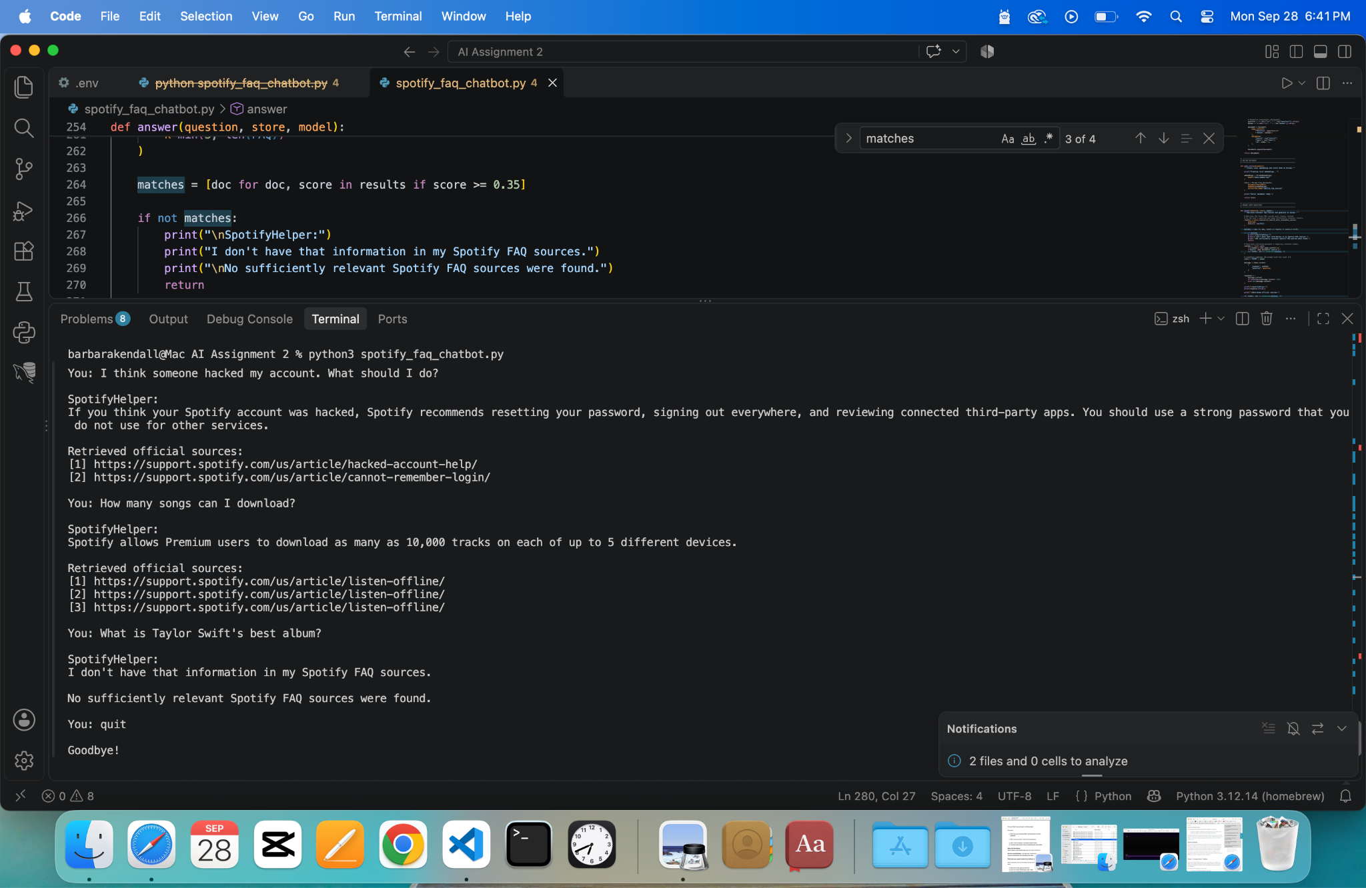
Figure 2. SpotifyHelper answering Spotify FAQ questions in interactive mode.
An important test involved asking a question that was intentionally outside the scope of the dataset:
“What is Taylor Swift's best album?”
During an earlier test, the language model attempted to answer this unsupported question and generated information that was not contained in the retrieved FAQ records. This exposed a weakness in the initial design. A relevance-score threshold was subsequently added to the retrieval process.
After this improvement, the same unsupported question resulted in:
“I don't have that information in my Spotify FAQ sources.”
The application also reported that no sufficiently relevant Spotify FAQ sources were found. This demonstrated that the relevance threshold improved the chatbot's ability to distinguish supported FAQ questions from unrelated questions.

Discussion and Insights
The project demonstrated that building an effective FAQ chatbot requires more than connecting a user question directly to a large language model. Retrieval quality, prompt design, dataset quality, and safeguards all influence the reliability of the final response.
One important observation was that semantic embeddings allow users to ask questions naturally rather than reproducing the exact wording of an FAQ. For example, the system correctly associated “songs” with “tracks.” This demonstrates an advantage of semantic vector retrieval over simple keyword matching.
Another important finding involved hallucinations. During testing, the language model initially responded incorrectly to a question about Spotify's download limit even though the correct information had been retrieved. It also attempted to answer a question about Taylor Swift that was outside the dataset. These failures demonstrated that successful document retrieval alone does not guarantee a grounded final answer.
The application was improved in two ways as a result. First, the prompt was strengthened to tell the language model to preserve numerical values and restrictions exactly as represented in the retrieved records. Second, a relevance threshold was introduced so that unrelated questions could be rejected before irrelevant retrieved information was used to generate an answer.
These changes demonstrate an iterative development process in which application behavior was tested, weaknesses were identified, and the system was modified based on observed results.
The project also has limitations. The dataset contains only 20 manually curated FAQ records, so it does not represent all information available through Spotify Support. Spotify may also change its policies, features, and support documentation over time, meaning that a manually maintained dataset can become outdated. A larger production application could automate the collection and updating of approved support information.
The relevance threshold is another limitation. A threshold of 0.35 worked for the tested examples, but a more extensive evaluation dataset would be needed to determine an optimal threshold. A threshold that is too high could reject legitimate questions, while a threshold that is too low could allow unrelated information into the prompt.
The local Llama 3.2 3B model also provides a practical compromise between accessibility and model capability. Running locally eliminates API costs and allows the application to operate without sending the FAQ prompt to a paid external LLM service. However, a relatively small local model may not follow instructions as consistently as larger models. The hallucinations discovered during testing illustrate why retrieval safeguards and systematic evaluation remain important.
Overall, SpotifyHelper demonstrates a functional NLP application combining semantic embeddings, vector retrieval, LangChain prompt management, a local LLM, and retrieval-augmented generation. The final application successfully answers supported Spotify questions while using relevance filtering to reduce unsupported responses.

References
LangChain. (n.d.). LangChain reference documentation. LangChain. https://api.python.langchain.com/
Ollama. (n.d.). Ollama documentation. https://docs.ollama.com/
Spotify. (n.d.). Listen offline. Spotify Support. https://support.spotify.com/us/article/listen-offline/
Spotify. (n.d.). Spotify Connect. Spotify Support. https://support.spotify.com/us/article/spotify-connect/
Spotify. (n.d.). Spotify is offline. Spotify Support. https://support.spotify.com/us/article/spotify-is-offline/
Spotify. (n.d.). Think your account's been hacked? Spotify Support. https://support.spotify.com/us/article/hacked-account-help/

